**Customer Service Request Analysis**

**Project Report**

**Aparna Nair**

**aparna.nair.vijay@gmail.com**

**Business Scenario**

NYC 311's mission is to provide the public with quick and easy access to all New York City government services and information while offering the best customer service. Each day, NYC311 receives thousands of requests related to several hundred types of non-emergency services, including noise complaints, plumbing issues, and illegally parked cars. These requests are received by NYC311 and forwarded to the relevant agencies such as the police, buildings, or transportation. The agency responds to the request, addresses it, and then closes it.

**Domain:**Customer Service

**Objectives**

Perform a service request data analysis of New York City 311 calls.

**Analysis Tasks**

1. Import a 311 NYC service request.
2. Read or convert the columns ‘Created Date’ and Closed Date’ to datetime datatype and create a new column ‘Request_Closing_Time’ as the time elapsed between request creation and request closing.
3. Provide major insights/patterns that you can offer in a visual format (graphs or tables); at least 4 major conclusions that you can come up with after generic data mining.
4. Order the complaint types based on the average ‘Request_Closing_Time’, grouping them for different locations.
5. Perform a statistical test for the following:

* Whether the average response time across complaint types is similar or not (overall)
* Are the type of complaint or service requested and location related?

**DATASET DESCRIPTION**

Dataset has 300698 observations of 53 variables

**Statistical algorithm execution – Python code and outputs**

Objective 1) Importing the libraries and csv file and analyzing the data



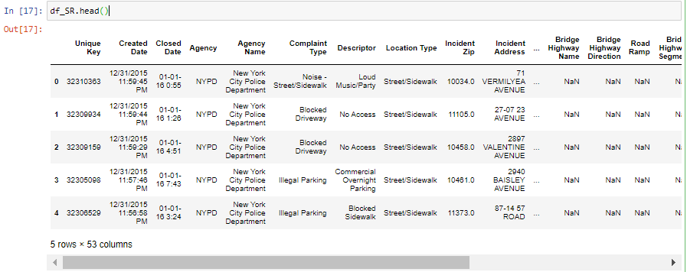

# Replacing the space in column name with ’_’

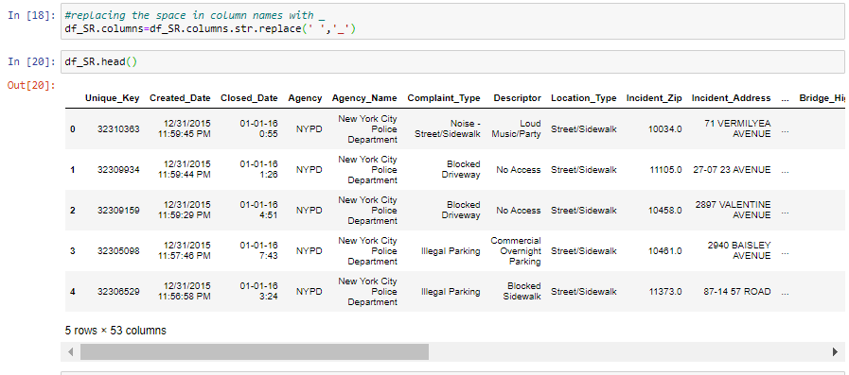



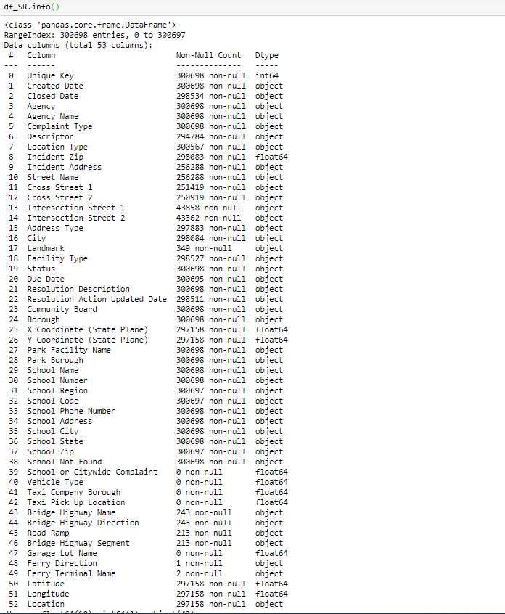

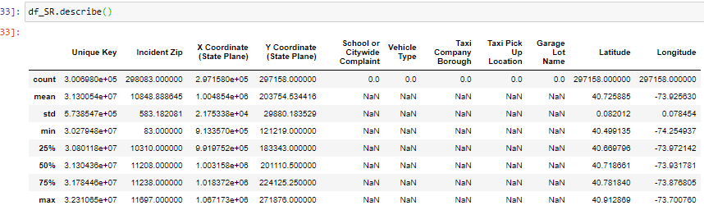

Objective 2 )Read or convert the columns ‘Created Date’ and Closed Date’ to datetime datatype and create a new column ‘Request_Closing_Time’ as the time elapsed between request creation and request closing

# Creating new fields for Created date and Closed date using datetime library

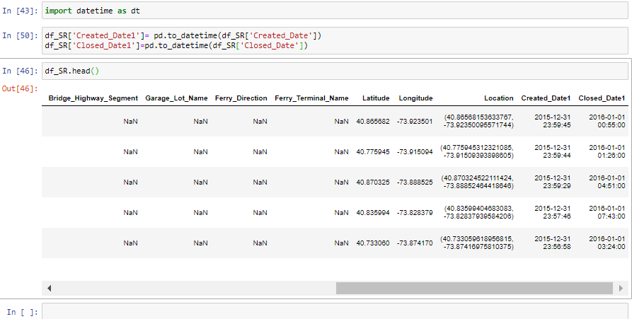

# Creating new field Request_Closing_Time

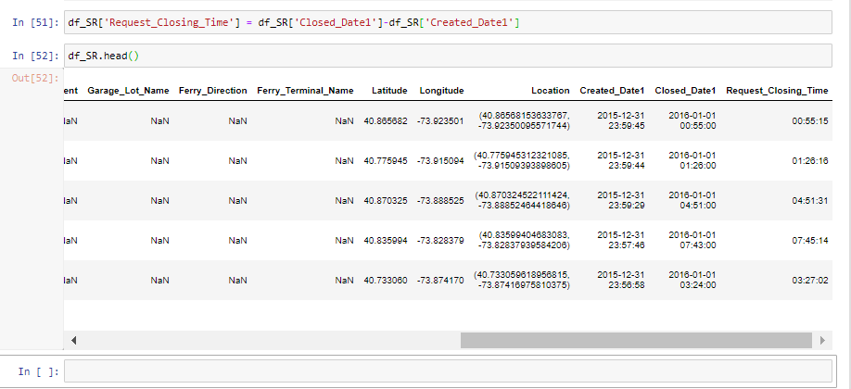

Objective 3 ) Provide major insights/patterns that you can offer in a visual format

# Blocked Driveway and Illegal parking are the complaint types with most request.

# Animal in a Park and Ferry Complaint are the complaint types with lowest request

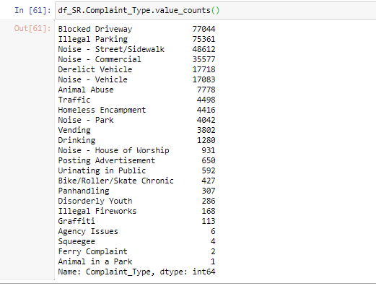

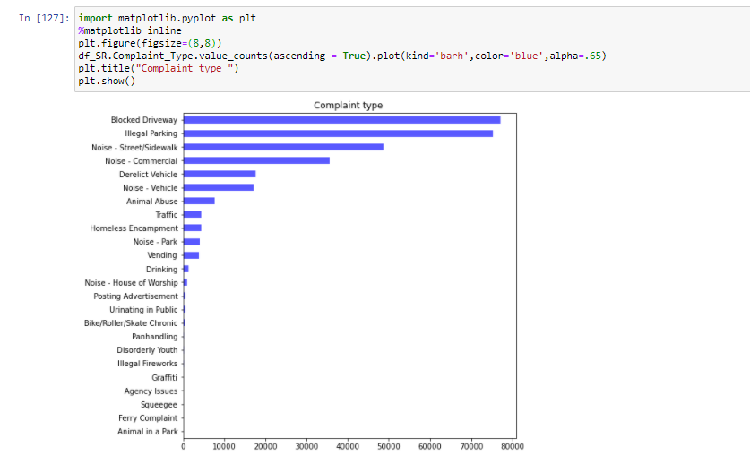

# Brooklyn is having the highest number of service request and Howard beach is having the least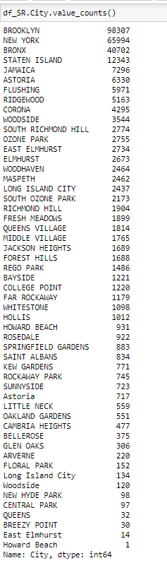

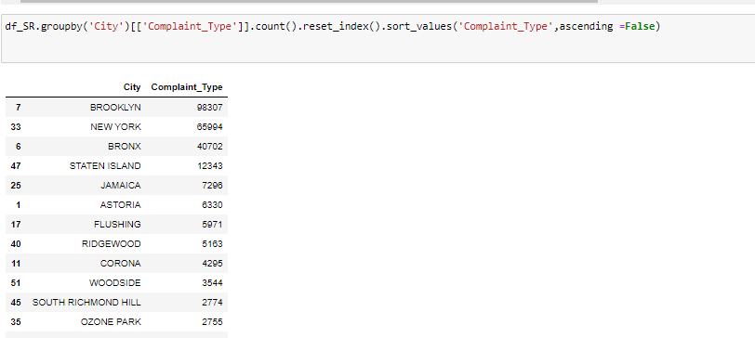

# Borough with highest service request is Brooklyn

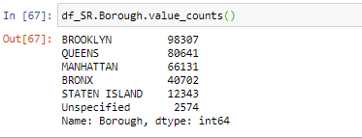

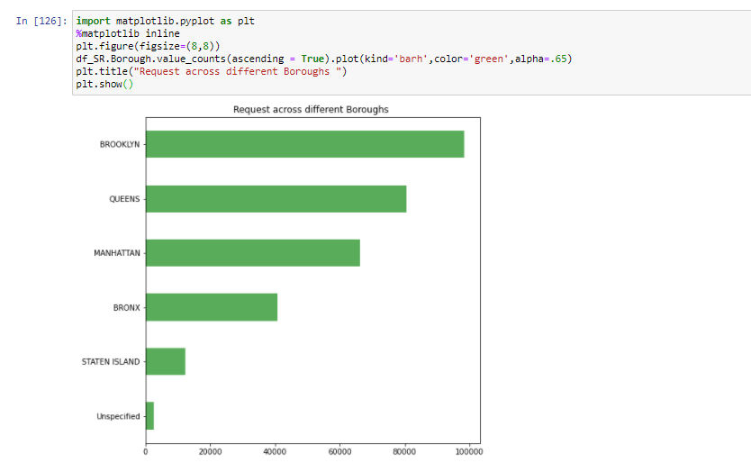

# High number of Service request are closed

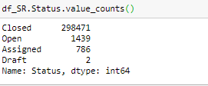

# Brooklyn is having the most number of closed cases for the complaint types Blocked driveway and Illegal Parking

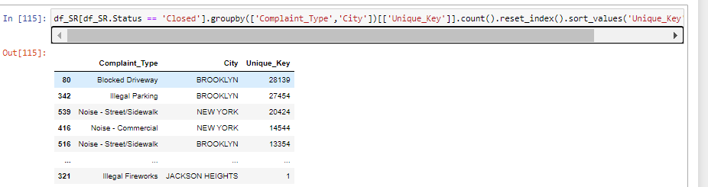

# Illegal Parking is having the most Open Request.

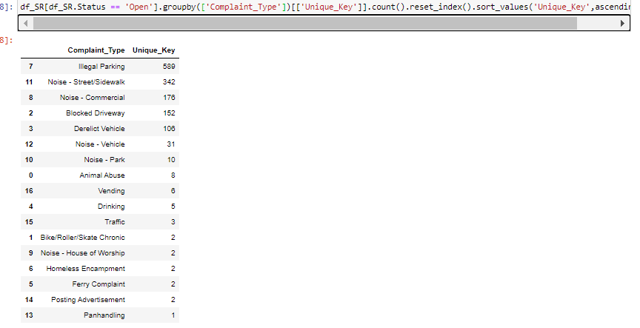

Objective 4) Order the complaint types based on the average ‘Request_Closing_Time’, grouping them for different locations.

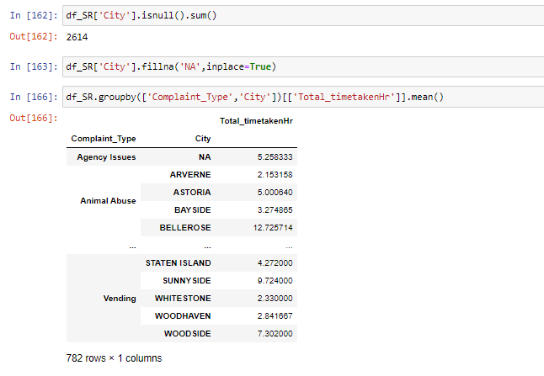

Objective 5)Perform a statistical test for the following:

Whether the average response time across complaint types is similar or not (overall)

Null Hypothesis Ho: Average response time across complaint types is similar

Alternate Hypotheis HA: Average response time is not similar across complaint types

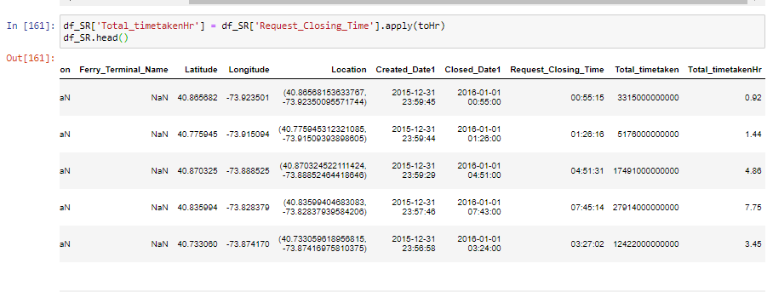

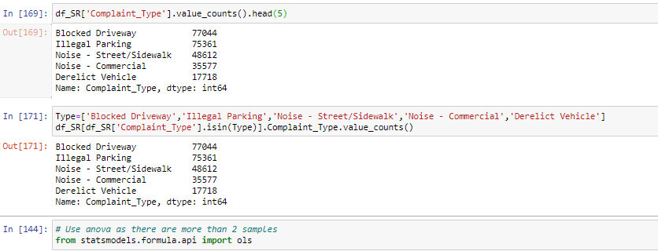

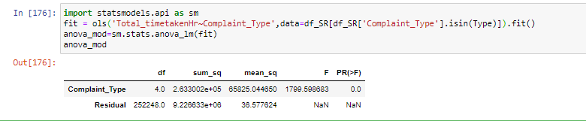

Since our p-value is lower that our critical p-value, we will conclude that we have enough evidence to reject Null Hypothesis .

Average response time for all the complaints type is not same

Are the type of complaint or service requested and location related?

# converting categorical variable to numerical variable



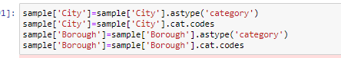

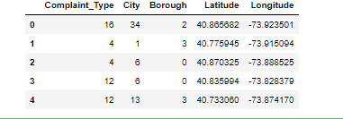

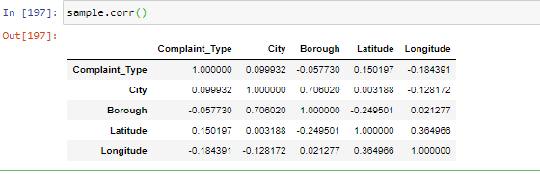

As there is very less correlation between Complaint type and City (0.09932) , Complaint type and City are not related

Result

Analysis Task

* Objective 1 - Import a 311 NYC service request.

Dataset was imported and analysed (Refer pages 4- 5)

* Objective 2 - Read or convert the columns ‘Created Date’ and Closed Date’ to datetime datatype and create a new column ‘Request_Closing_Time’ as the time elapsed between request creation and request closing.

Converted the columns Created Date and Closed Date to datetime datatypes and a new column Request_Closing_Time(Refer page 5-6)

* Objective 3 - Provide major insights/patterns that you can offer in a visual format (graphs or tables); at least 4 major conclusions that you can come up with after generic data mining.
* Major Insights drawn were (Refer pages 7-11):
  + Brooklyn is having the highest number of service request and Howard beach is having the least
  + Blocked Driveway and Illegal parking are the complaint types with most request
  + Brooklyn is having the most number of closed cases for the complaint types Blocked driveway and Illegal Parking
  + High number of Service request are closed
  + Illegal Parking is having the most Open Request.
* Objective 4 - Order the complaint types based on the average ‘Request_Closing_Time’, grouping them for different locations.

Complaint types was ordered based on average Request_closing _Time grouped for different locations (Refer page 12)

* Objective 5 - Perform a statistical test for the following:

Please note: For the below statements you need to state the Null and Alternate and then provide a statistical test to accept or reject the Null Hypothesis along with the corresponding ‘p-value’.

* Whether the average response time across complaint types is similar or not (overall)
* Are the type of complaint or service requested and location related?

Average reponse time across complaint types are not similar

Type of compliant and location are not related ( Refer pages 12-14)